- We forecast that UK CPI inflation will average 3.2% in 2025, slightly higher than projected last month. This reflects the announcement that water bills will increase sharply in April and our weaker forecast for sterling, which points to greater upward pressure on imported goods prices.
- January's rise in inflation was largely as expected, with the services and food categories the primary drivers of the increase. We expect inflation to remain elevated throughout this year due to higher energy prices, weaker sterling, and firms passing on some of the rise in labour costs.
CPI inflation rose to 3% in January, from 2.5% in December. The increase reflected two key drivers. First, services inflation accelerated due to the unwinding of December's temporary weakness in the erratic air fares sub-category and the imposition of VAT on private school fees. Second, there was a notable rise in food prices, though this was partly due to base effects caused by an unusually weak reading last January. Together, these factors were more than enough to offset a slightly larger drag from the energy category, as the 1.2% hike in the energy price cap was much smaller than the increase a year earlier. Elsewhere, RPI and RPIX inflation climbed to 3.6% and 3.2% respectively in January, from 3.5% and 2.9% in December.
We expect that CPI inflation will edge downwards over the next couple of months before rebounding again from April, with the energy price cap set to rise by more than 6% that month. We then expect inflation to remain above 3% for the rest of 2025. The depreciation in sterling in recent months will push up the prices of imported goods, while we expect firms to pass on some of the rise in labour costs caused by increases in employers' national insurance contributions and the national living wage.
The pickup in inflation this year is likely to be slightly stronger than we previously forecast. This is partly due to the announcement of hefty increases in water bills, which are set to take effect from April. We also expect sterling to remain weaker against the dollar, with the Federal Reserve likely to loosen policy more gradually than we previously thought. Overall, we now expect CPI inflation to average 3.2% this year, up from 3% last month.
Chart 1: Higher water bills and weaker sterling have raised our 2025 inflation forecast to 3.2%
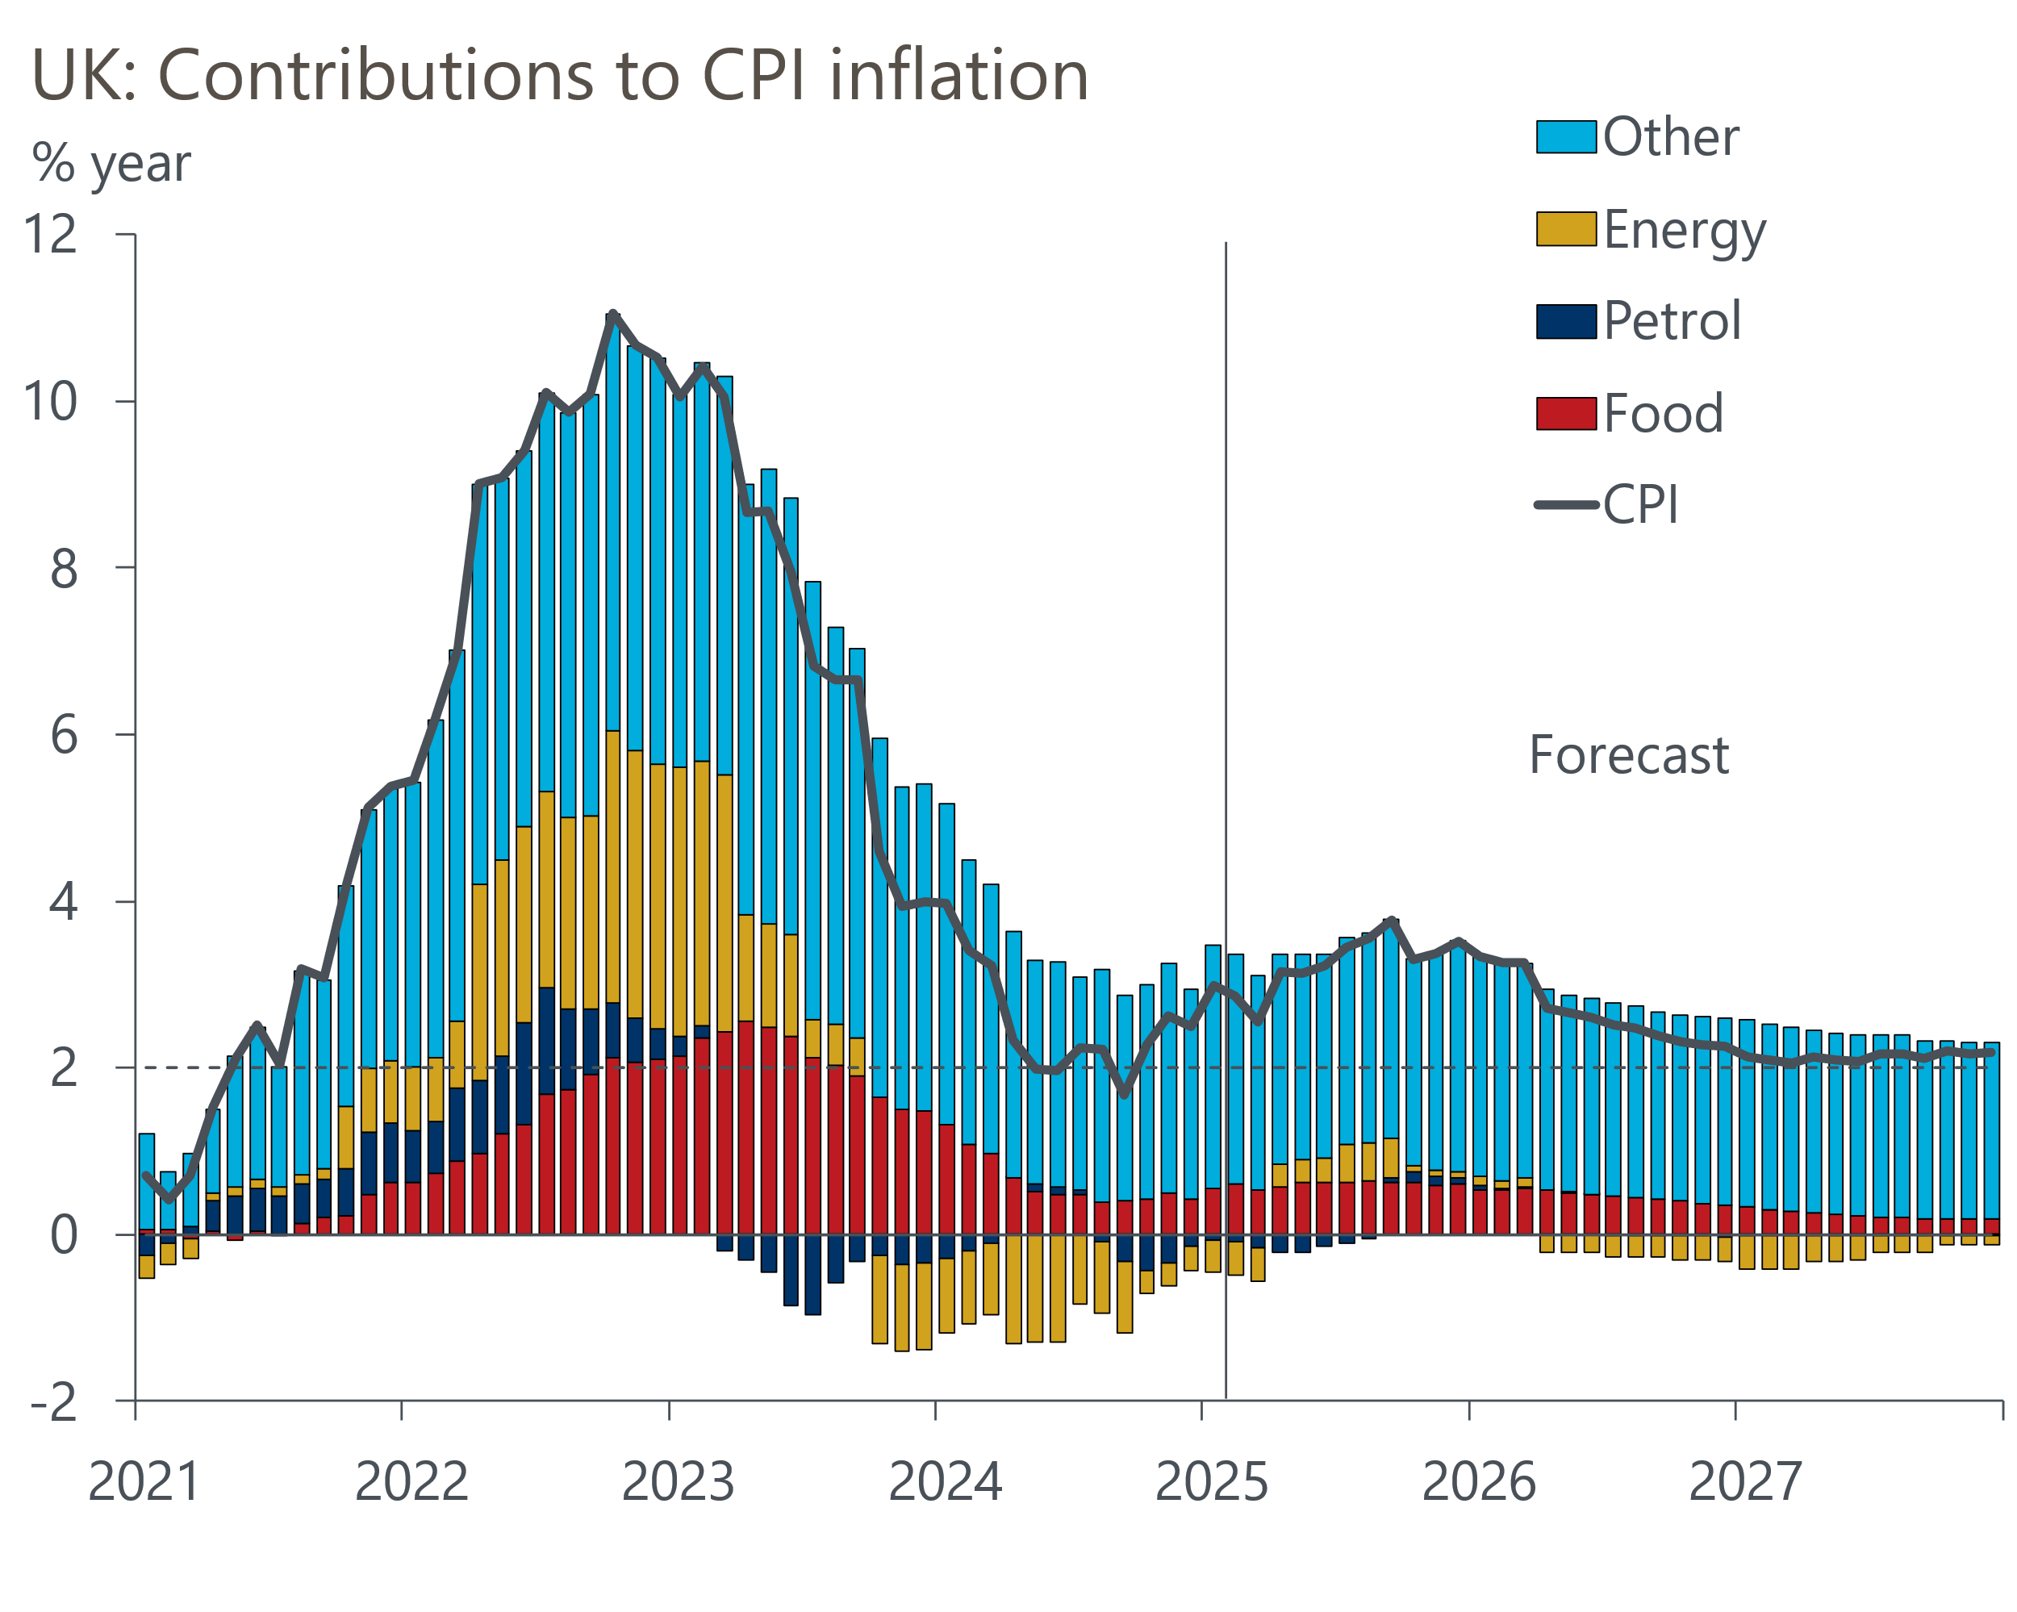
Source: Oxford Economics, Haver Analytics

